Michal Bochenek  
EC1401916

Multimedia:   
**Developing Multimedia Applications DH2R34/004**  
  
Outcome 3:   
**Implement a multimedia application based on the design specification.**

Table of Contents

1. Introduction. 2

2. Media sources and acquisition evidence. 2

3. Interface objects properties. 4

4. Handling of keyboard and mouse events. 6

# Introduction.

This document lists and describes multimedia application elements, methods and legislation background which were used or based on in order to create the legislation following and working prototype.

# Media sources and acquisition evidence.

To create this prototype application a number of free open sources were used such as:  
  
a) jQuery mobile (https://jquerymobile.com/)  
This is a HTML5 based user interface system created to make responsive websites and applications which are accessible via smartphone, tablet and desktop devices. It allowed us to create a cross-platform application that can be run in any device using modern internet technologies.  
  
b) jQuery mobile YouTube as a gallery plugin (https://plugins.jquery.com/youtubevideogallery/) this small but powerful plugin allows us to make and arrange a gallery of YouTube videos and display them using jQuery UI.

c) JavaScript (https://www.javascript.com/) – this is a powerful scripting language which makes website/application more responsive and tailored to suit the user and developer needs.  
  
d) Theme Roller for jQuery mobile (http://themeroller.jquerymobile.com/) - a customised theme for the website was built up using this tool.  
  
Graphical elements were created with use of basic tools in-built within Windows 8.1 like MS Paint or taken from the jQuery available icon sets and modified using CSS3 stylesheets.  
  
Other elements were taken from the internet for testing purpose only and should be removed before releasing the project to the wider public and replaced with EC RockBand own items and objects.  
  
A free sound sample (…/media/sample.wav) is used as a placeholder for EC RockBand tracks and it is suitable for carrying on the tests.   
  
YouTube video links are not a subject of copyright protection and thus it is allowed to use them for the prototype and later EC RockBand can use their own YouTube profile videos for the application without gaining allowances from the company as long as no fees are required to be paid by the user as this would break company policies.  
  
The design was based on the accordance with the Fair Dealing law in the United Kingdom (https://en.m.wikipedia.org/wiki/Fair_dealing_in_United_Kingdom  
_law) which allows limited use of some content elements if there is no profit gained on the use of them such as book covers, music album covers, short citations of the content (like the back page of the book) etc.

# Interface objects properties.

Interface objects were realised by using jQuery mobile tools such as:

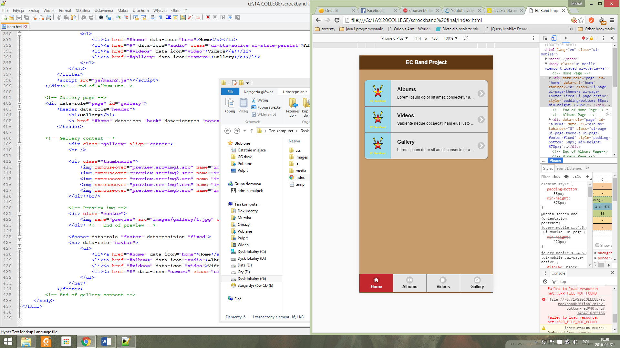data-role for describing an object role in the code:

* content - to create space for the main content display   
  - header - for navigation and marking the beginning of new content to start  
  - listview - to create a list  
  - footer - for making a usable space at the bottom of the content and mark the end of the part of the page  
  - navbar - to create a navigation bar fixed at the expected position

Icon pictures were made by using a data-icon option which is native for jQuery and placed in the code downloads a requested button icon.  
  
Example: navigation bar on the bottom of the page:  
  
<nav data-role=**"navbar"**>

<ul>

<li><a href=**"#"** data-icon=**"home"** class=**"ui-btn-active ui-state-persist"**>**Home**</a></li>

<li><a href=**"#albums"** data-icon=**"audio"**>**Albums**</a></li>

<li><a href=**"#videos"** data-icon=**"video"**>**Videos**</a></li>

<li><a href=**"#gallery"** data-icon=**"camera"**>**Gallery**</a></li>

</ul>

</nav>

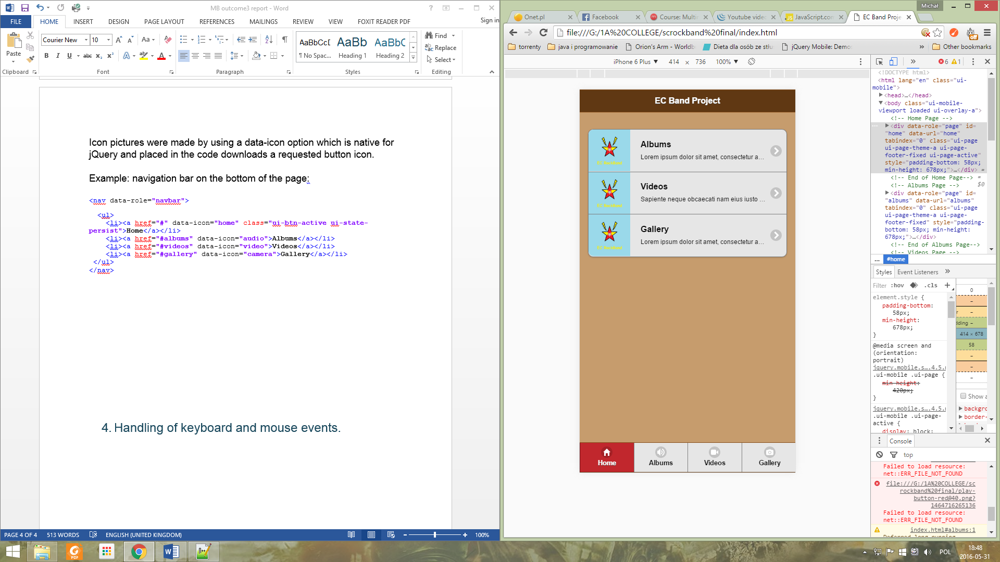

Videos are displayed fully by using YouTube native UI which wasn’t modified for the purpose of the project.  
  
Audio player and gallery elements on the other hand were made with the use of JavaScript language and applying it to the objects which would be otherwise unusable in HTML5 code like picture of a “play” button.  
  
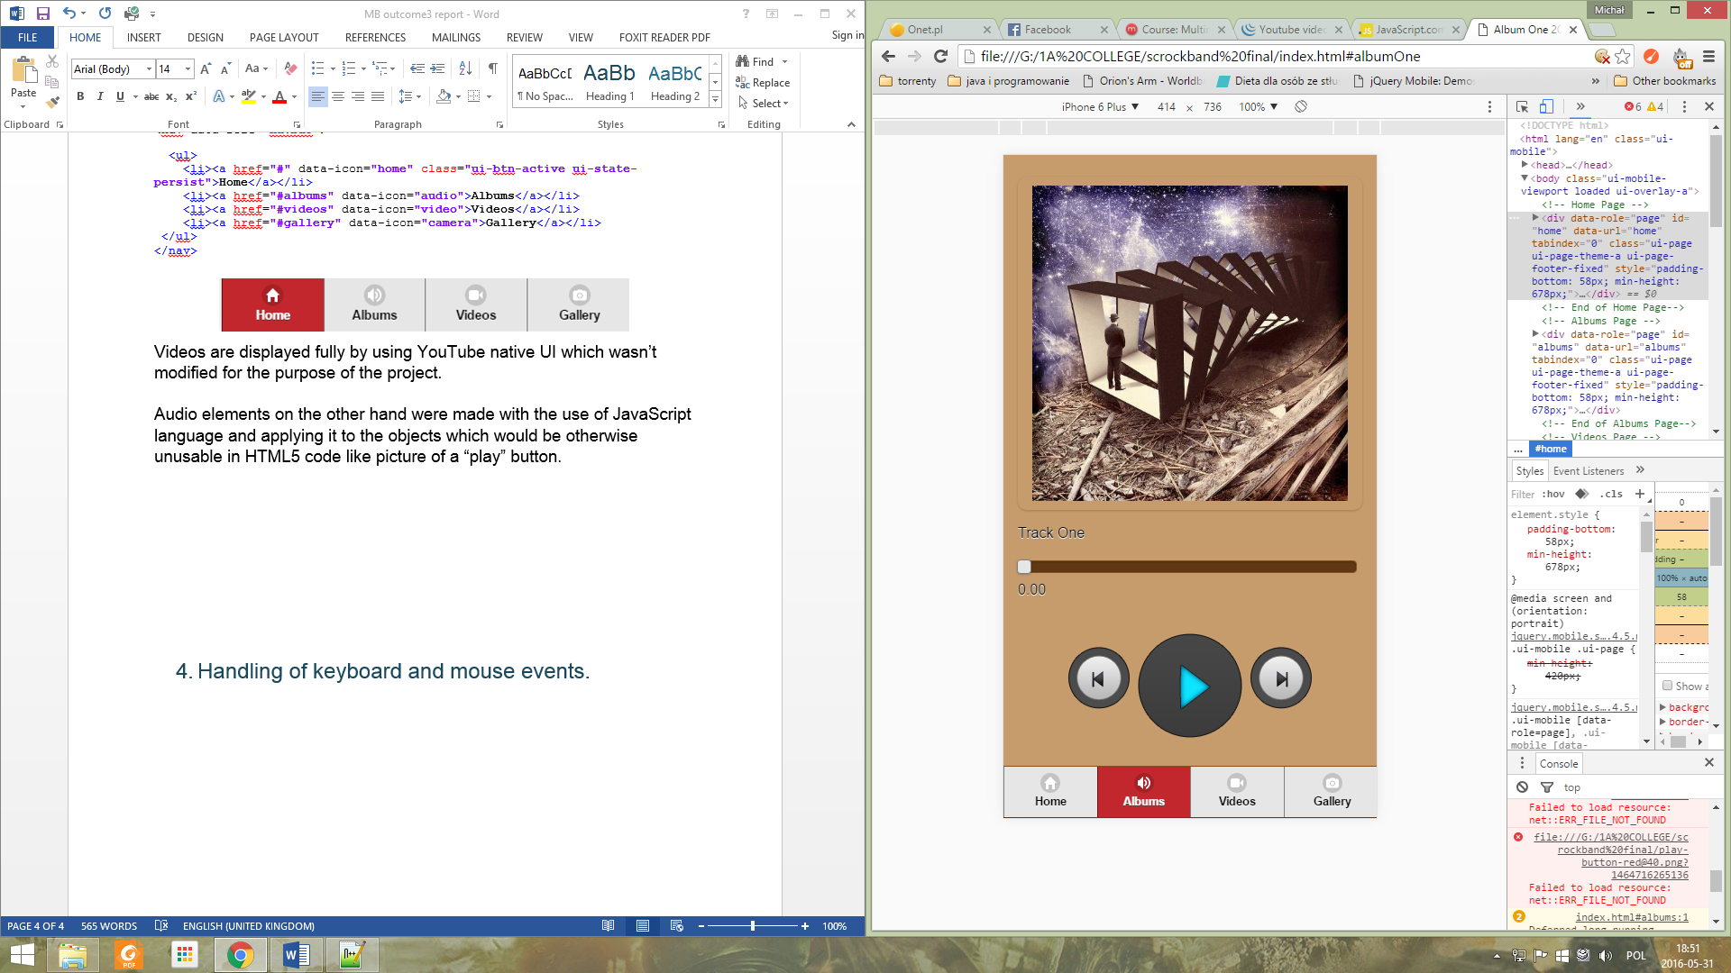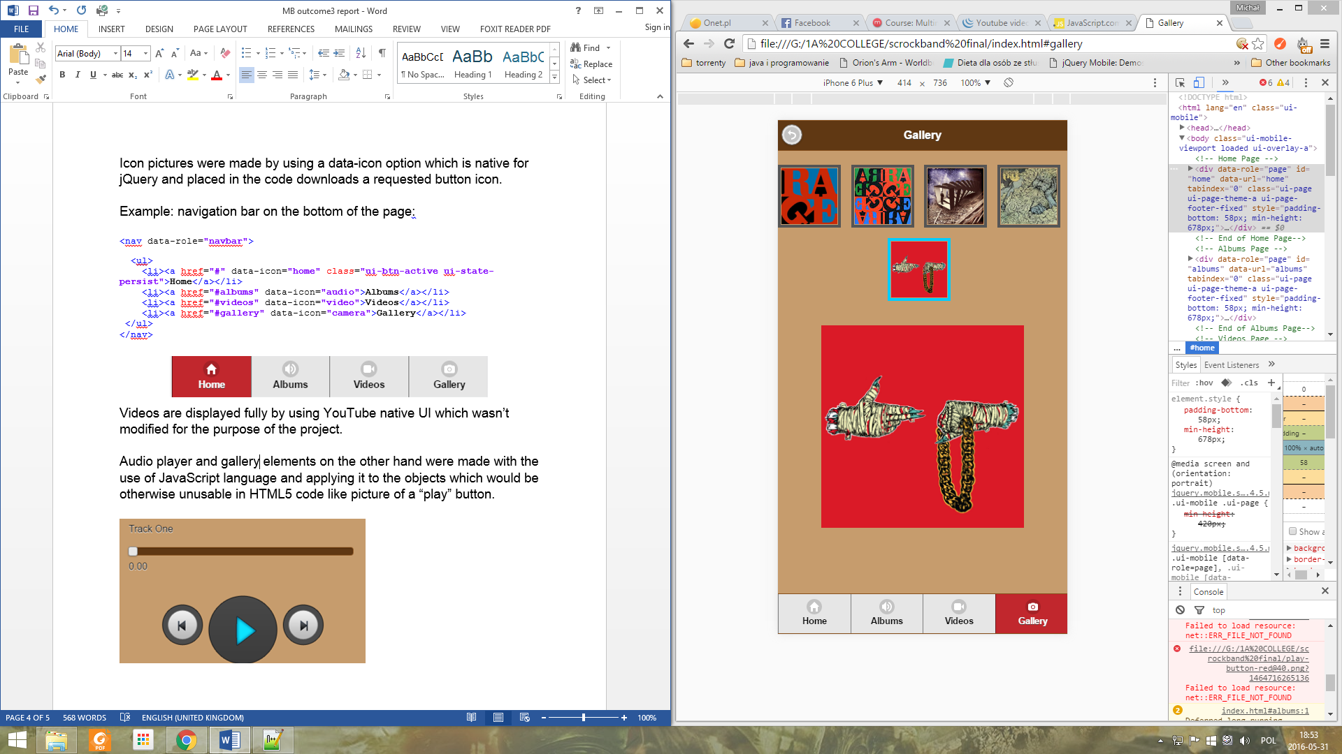

# Handling of keyboard and mouse events.

Keyboard and mouse events were created with the use of HTML5 and mainly realised and modified by JavaScript and CSS3 code.  
  
The designed application contains no form elements or inputs and the use of buttons and hyperlinks is well applied so there is no need for typing on the keyboard, only tapping or clicking is required.

This example code below makes an image representing play button play the audio record and replaces itself with “pause” image which stops playing record at the current position, event is created when clicking on the graphical object.  
  
// Play Button

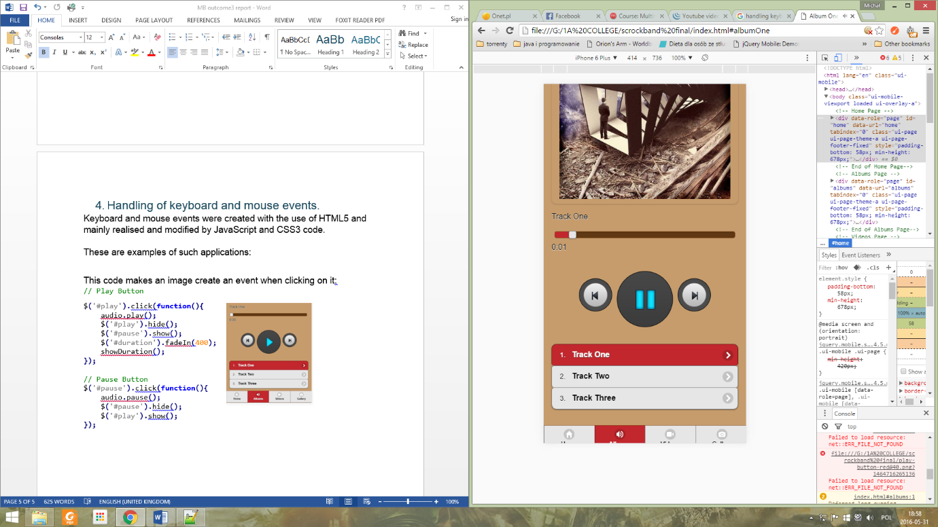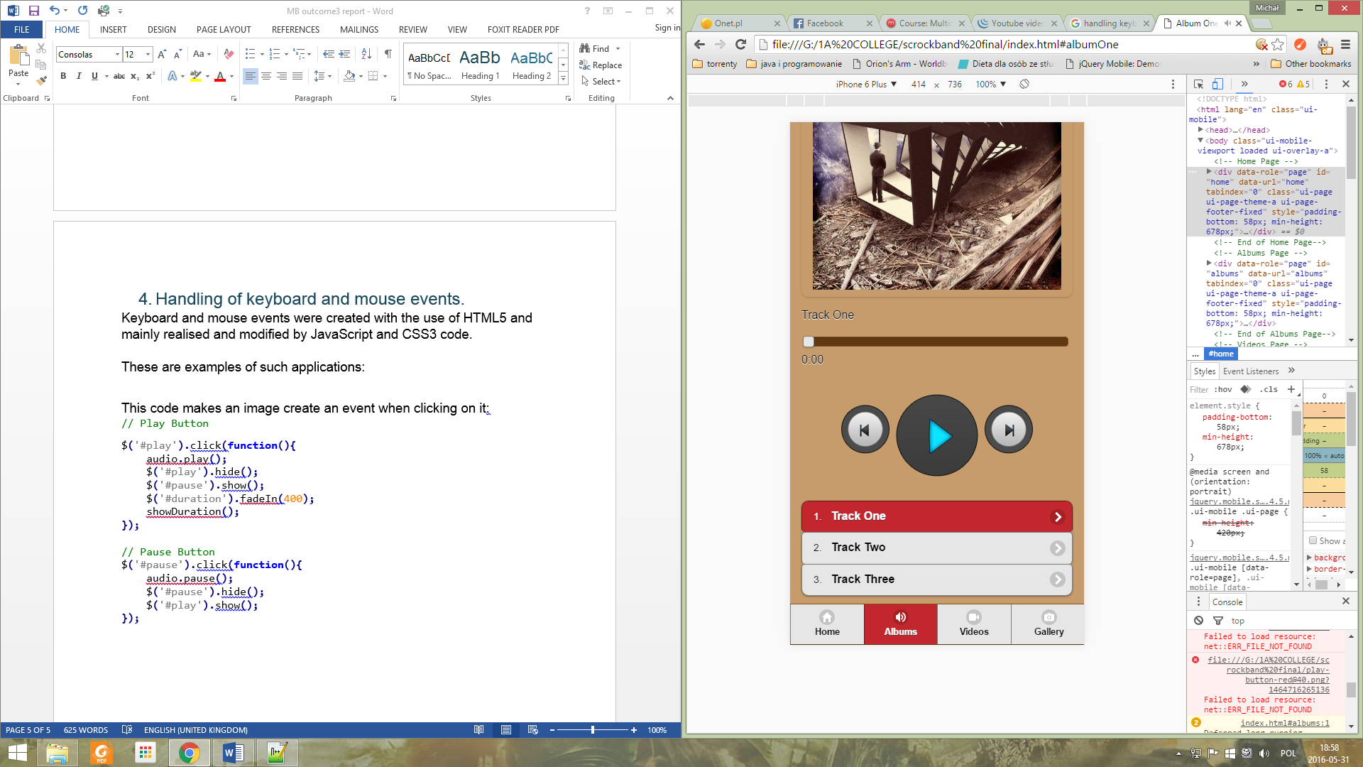$**(**'#play'**).**click**(function(){**

audio**.**play**();**

$**(**'#play'**).**hide**();**

$**(**'#pause'**).**show**();**

$**(**'#duration'**).**fadeIn**(**400**);**

showDuration**();**

**});**

// Pause Button

$**(**'#pause'**).**click**(function(){**

audio**.**pause**();**

$**(**'#pause'**).**hide**();**

$**(**'#play'**).**show**();**

**});**

Other elements such as progress bar, next and previous track were made using the same principles and full code is placed and accessible in …js/main.js and …js/main2.js.  
  
All elements are used in correct manner such as return button has an arrow heading backwards symbol, home page is shown as a house symbol icon, music albums are presented as speaker, videos are camera icon and gallery represents camera symbol.